Implementing an Information System for Reporting Cases of Missing, Abducted, Runaway, Throwaway, Abandoned, Found and Unidentified Persons

Rey Vincent P. Babilonia
March 2009

This project is submitted to the Faculty of Information and Communication Studies in partial fulfillment of the requirements for the degree Master in Information Systems at the University of the Philippines – Open University, Los Baños, Laguna. It is the product of my own work except where indicated in the text. The project report or any portion thereof including the source code or any section may be freely copied and distributed provided that the source is acknowledged.

This project entitled “Implementing an Information System for Reporting Cases of Missing, Abducted, Runaway, Throwaway, Abandoned, Found and Unidentified Persons” submitted to the Faculty in Information and Communication Studies, University of the Philippines – Open University, Los Baños, Laguna in partial fulfillment of the requirements for the degree Master of Information Systems is hereby accepted.

_____________________
Dr. Concepcion Khan
Faculty-in-Charge, IS 295B
Date: ________________

_____________________
Dr. Alexander Flor
Dean, Faculty of Information and Communication Studies
Date: ________________

Acknowledgment
I thank the Advanced Science and Technology Institute for giving me the encouragement to take up graduate study, for opening up doors to new and exciting researches and for providing some leniency at work.
I am likewise grateful to Marvic Orejo whose patience and understanding inspired me to finish this project.
A debt of thanks is also due to Sir Arthur Conan Doyle's Sherlock Holmes whose genius allows me to think outside the box.

Abstract
The lack of a centralized service for disseminating advisories, the need for a joint effort for finding missing Filipinos and the absence of a free and open source information system for reporting missing persons are the three issues identified as detrimental to reuniting family members that got separated. Hence, an open source Missing Persons Information System was developed.
This project falls under the e-Government domain with the objectives of implementing an information system that will integrate and consolidate all government efforts in finding missing, abducted and runaway persons and reporting throwaway, abandoned, found and unidentified persons; informing and encouraging citizens to look out for these missing persons; and promoting awareness for the public in keeping their relatives safe.
The target beneficiaries are the proposed Missing Persons Council or Commission on Missing Persons, the Philippine National Police, the National Bureau of Investigation, the Department of Social Welfare and Development, the missing and found persons, their relatives and the general public.
The linear sequential model of system development process was followed which suggests a systematic, sequential approach to software development that begins at the system level and progresses through analysis, design, coding, testing and maintenance.
For the design studies, books, articles and tutorials on JSP, Java, Struts and iBATIS were read and existing systems were reviewed to acquire designs, standards and best practices. General systems theory was used to view the interaction of unique elements as a whole.
The project can be considered a success if all the requirements and issues have been addressed, the code has been released into the public domain and a sandbox has been deployed for the country. Further measure of success are the performance of the investigators assigned to cases and the number of missing persons reunited with their families.
Table of Contents
Acknowledgment 4
Abstract 5
I. The Problem Domain 8
A. Statement of the Problem 8
B. Background and Objectives of the Project 8
C. Significance and Scope of the Project 11
D. Documentation of Existence and Seriousness of the Problem 12
II. Review of Existing Alternatives 15
III. Approach to be taken in this subject 17
A. Theoretical Framework 17
B. Rationale for the framework 20
C. Technologies used 22
IV. Project Plan 23
A. Concept 23
B. Methods 33
C. Plan for user testing and project assessment 34
D. Plan for collaboration (For collaborative projects only) 35
V. Results and Discussions 36
VI. Conclusions 41
VII. Recommendations 42
VIII. References 44
VI. Appendices 48
A. Deliverables and Milestones 48
B. Budget 48
C. Qualifications 48
D. Contributors / Collaborators 51
E. Resources 52
F. Complete Program Listing 52
G. Technical Reference 54
H. User Manual 55
I. List of Figures 55

I. The Problem Domain

A. Statement of the Problem
A number of Filipinos are reported missing every year (Philippine Senate, 2007). The Philippine National Police (PNP), the National Bureau of Investigation (NBI) and the Department of Social Welfare and Development (DSWD) are tasked to initiate action in finding these persons. However, there is no centralized service for disseminating advisories to and requesting help from the public; there is no consolidated effort for locating missing Filipinos; and there is no free, open source and operational information system currently available for download that could address these problems.

B. Background and Objectives of the Project
In an attempt to integrate information systems and high-performance computing, a weather sensor grid and computing-intensive forensic applications were identified as initial research topics before considering parallel digital image processing. Age progression on pictures of human faces takes a raw image as input and a set of other images from varying age groups as training data. Various algorithms for and implementations of age progression have been developed but none of them were utilizing the message parsing interface (MPI) library to take advantage of the power of a high-performance computing cluster. These age simulated faces can be used for finding persons who have gone missing for a very long time.
With this in mind, a missing persons information system (MPIS) was conceived. This MPIS consists of 2 modules: a Java version of an age progression software with the help of the mpiJava library for the computation and a Web-based frontend using Java Server Pages (JSP) for the dissemination of information and images to a large population. However, the first module does not belong to the realm of information systems and time and resources are essential. These reasons narrowed down the project to just the Web component of a missing persons database.
A simple query on national efforts on finding missing persons led to an article stating that Senator Jinggoy Estrada refiled Senate bill 429 creating the Commission on Missing Persons (Philippine Senate, 2007). The proposed commission's aims include the following: to conduct investigations of missing persons, to initiate policies and programs towards an effective communication system to aid the search of missing persons and to devise a system of raising the consciousness of the people and for them to inform the Commission of people who are found loitering in public places, tramping or wandering about aimlessly. This commission shall be composed of the Chairman of the Human Rights Commission (CHR), the Director General of the PNP, the Director of the NBI, the Chairman of the National Police Commission (NAPOLCOM), the Secretary of DSWD and 2 members from the private sector whose advocacy is on human rights (Estrada, 2007).
Similarly, Senator Manny Villar proposed Senate bill 1709 establishing the Missing Persons Council. The council will be composed of the Secretary of Justice, the Chairman of CHR, the Chief of PNP, the Director of NBI and the Secretary of Social Welfare and Development. This council aims to coordinate all national efforts to suppress and eradicate cases of missing persons in the country, to conduct its own investigation of missing persons, to monitor the investigations conducted by the PNP and NBI, to establish and maintain comprehensive database information systems on the cases of missing persons including their identities and other interested parties and to grant monetary rewards and other incentives to informers who give vital information, among others (Villar, 2007).
Senator Loren Legarda, in her Senate bill 1385, seeks to establish a National Strategic Missing Children Recovery Program which will aid in returning these children to the care and protection of their parents or legal guardians. This bill will be instrumental in forming the Sectoral Panel on Missing Children of the Council for the Welfare of Children which will be under the Department of Social Welfare and Development (Legarda, 2007).
A missing persons database will be a concrete and central component for reporting missing, abducted or lost relatives and homeless or unidentified citizens; initiating collaborative search operations; and tracking the status of cases.
Agencies which have an information system in place include the United States' Federal Bureau of Investigation (http://www.fbi.gov/wanted/kidnap/kidmiss.htm), National Center for Missing and Exploited Children (http://www.missingkids.com) and National Center for Missing Adults (http://www.theyaremissed.org/ncma/index.php), Canada's National Missing Children Services (http://www.ourmissingchildren.gc.ca/omc/index_e.htm) and United Kingdom's Missing People (http://www.missingpeople.org.uk). These systems are developed in-house and some can create age-progressed images of missing children to predict how they would look like later on. However, the system is neither for sale nor for download and age prediction takes a few days to complete.
My research topic aims to implement an information system that will integrate and consolidate all government efforts in finding missing, abducted and runaway persons and reporting throwaway, abandoned, found and unidentified persons; to inform and encourage citizens to look out for these missing persons; and to promote awareness for the public in keeping their relatives safe. A free and open source JSP-based application using the Model-View-Controller (MVC) architecture was developed. It can display profiles of missing Filipinos with a report sighting feature and can perform data encoding online unto a MySQL database. The finished Open Source Missing Persons Information System (OpenMPIS) is very customizable and can be easily deployed by a centralized government agency mandated for finding missing people. Parallel digital image processing for age progression can be integrated to this system later on.

C. Significance and Scope of the Project
The project will give significance to the following areas:
- Aid for the authorized government agencies
The National Bureau of Investigation, the Philippine National Police and the Department of Social Welfare and Development can access this system. They can encode a missing person's information, update the status of a case and assign assets to a case.
- Advisory for and participation of the general public
The public will be informed about the identities of missing persons online. Their cooperation will also be solicited in reporting to the authorities the whereabouts of these persons. The system provides contact details and reporting procedures in case one of their relatives go missing.
- Assistance for the person and relatives
The missing, unidentified or found person will have investigators working on their case. Relatives can receive up-to-date monitoring of the agencies' search operations. They can be reassured that the government is doing its best in locating their loved ones.
The project is limited to the information system module. Web and database servers were set up. Dynamic Web pages for viewing profiles of missing, found and unidentified persons; managing encoder accounts; encoding records and uploading pictures; assigning personnels to cases; contacting authorities; and displaying statistics were also created. The age progression feature will not be implemented due to time and resources constraints. The geographic information system module which can visually display the location where persons disappeared from will be implemented at a later date.

D. Documentation of Existence and Seriousness of the Problem
Chalana (http://sourceforge.net/projects/chalana), also known as FindThem (http://sourceforge.net/projects/findthem/), is a free and open source missing persons information system from Sri Lanka that is still under development thus, no software release has been made yet. The process and data models have not been discussed.
Sahana (http://www.sahana.lk/) and Mass Casualty Disaster Data Collection (http://sourceforge.net/projects/pcrx911/) are disaster management systems that have a simple submodule for missing persons. One can post names of missing persons during a calamity like tsunamis and landslides and track the distribution of refugees and relief goods. MCDDC is still under development and the process and data models have not been described. Sahana, developed by the Sri Lankan FOSS community, employs a modularized architecture and component-based development for missing person registry, organization registry, request management system, camp registry, volunteer management, inventory management and situation analysis. Sahana is a PHP Web application with data stored on a MySQL database server. Information on missing persons, relief organizations, evacuation center or camp, aid pledges and requests, inventories, volunteers and situations can be captured and disseminated to those who need them.
The Web sites of NBI and DSWD do not have links to their missing persons database. The PNP integrated the most wanted list with the missing persons but the link doesn't lead anywhere (http://www.pnp.gov.ph/pcr/content/mostwanted/info/body.html).
Statistical data relevant to proving the existence and seriousness of the identified problems are not available because NBI, PNP and DSWD have not published any. However, human rights advocacy group KARAPATAN counts 196 enforced disappearances under the Arroyo administration (Philippine Senate, 2007). This does not include disappearances under normal circumstances.
Matthew “Chu-Chu” Samudio, a three-year old boy from Putatan, Muntinlupa, was abducted on July 22, 2008 at the Festival Mall in Alabang. Chu-Chu was used by a syndicate to beg in the markets of Sta. Rosa, Laguna. He was found three days later.
Ma. Ysabelle “Ysa” Sim, a two-year old girl, was snatched while playing in front of their house in Pandacan, Manila on November 23, 2006. This was featured on Jessica Soho's “Sana'y Muling Makapiling (Reunions)” on QTV. In December 2007, the family was informed that Ysa was found somewhere in Surigao. Apparently, she was sold to a childless couple in Surigao del Sur. Ysa, now turning four, is under the care of an adoptive family. Her father and grandmother appealed to DSWD to help them recover her.
Sherry Ann Salac, a 23-year old female, left their house in Tonsuya, Malabon on May 20, 2007 without telling anyone where she's going. She did not run away for she did not bring any of her things. Her body was found in Nueva Ecija.
Other cases of missing persons can be viewed at http://telebisyon.net/Reunions/series/comments/.

II. Review of Existing Alternatives
The PNP, NBI and DSWD were emailed so as to get a better information as to how they cope with the problem of finding missing persons but they have not replied. The fact that their Web sites do not have the information on missing and found persons illustrates that they do not have the necessary tool for this problem.
The best available resource for addressing this problem is to have a publicly-accessible and updated information system that will enable these 3 agencies and the proposed Missing Persons Council or Commission on Missing Persons to encode missing persons' data, assign personnels to handle cases and monitor the search progress.
The following existing and current best practices were utilized:
- Version control and version rules
For any software development project, it is important to have a version control system to handle on-going and outdated versions of source codes. This facilitates bug detection and software releases. Version rules pertain to a uniform way of documenting code changes. The source code is being hosted at http://openmpis.googlecode.com and it can be downloaded using Subversion.
- Model-View-Controller architecture
For a Web application, it is best to utilize the Model 2 architecture to mitigate and accurately pinpoint bugs and to separate the presentation from the business logic. Apache Foundation's Struts framework made it easier.
- Data mapping
Data mapping allows the use of persistent objects mapped to SQL statements using an XML descriptor. Apache Foundation's iBATIS simplified the persistence of data.
- Uniformity in tabs, braces and comments
To ensure readability, there should be uniformity in tab sizes, positioning of braces and structure of comments, among other things. The NetBeans IDE made it possible to automate comment generation and increase readability.
- Manuals
User and administration manuals guarantee smooth operations in the usage and management of the system
- Standard method and attribute names
Adherence to standard method and attribute names also promote uniformity. File names can be easily recognized and return values can be handled correctly.
- Identifiable data types
Certain instances of objects and variables can be identified clearly when they are shared with other classes and packages if they carry their data type in their name.

III. Approach to be taken in this subject

A. Theoretical Framework
The General Systems Theory (GST) was used to illustrate the underlying concepts and relationships of actors with respect to the Information System. GST relies on independent factors or constructs like input, throughput, feedback, control, environment and goal to produce an output (Wade, 2005). Instead of reducing an entity to the properties of its parts or elements, systems theory focuses on the arrangement of and relations between the parts which connect them into a whole. This particular organization determines a system, which is independent of the concrete substance of the elements (Heylighen and Joslyn, 1992). All the interaction between the relatives, encoders, victims and investigators makes this information system an ideal case study for GST. Furthermore, systems concepts like system-environment boundary, input, output, process, state, hierarchy, goal-directedness, and information can easily be identified within MPIS.
GST strengthened the foundation of most commercial software design techniques in the 1970's and was used to design the "missing link" transformation from system analysis (defining what's needed in a system) to system design (what's actually implemented) using the Yourdon/Demarco notation during the 1980's (Wikipedia 1).
GST provides an internally consistent framework for classifying and evaluating the world, in this case, the Philippine society. GST also provides a scholarly method of evaluating a situation. GST can also mitigate expenses by avoiding unnecessary duplication of efforts (Walonick, 2004). It is fairly common to have competing open source applications boasting various features. Things would have been simple if all the strengths were added together to form a powerful software. If this isn't practical, coming up with a standard would be beneficial to all parties involved. By being aware with principles from other fields or competitors, adapting their theoretical structure could cut expenditures, time and effort.
The following system design principles were utilized (Wikipedia 2):
- Extensibility
New features and functionalities through various pages, actions and data transfer objects can be developed and added to the information system while only the configuration and property files will be modified.
- Robustness
The information system can still function properly even if there are plenty of concurrent users and visitors accessing the site. It should also be able to safely handle errors in input and return appropriate notifications.
- Reliability
The information system must be able to perform a specific function under stated conditions for a specified period of time.
- Fault-tolerance
The information system should be resistant to and able to recover from component failure. Having backups are important in case properly installed and configured Web and database servers do fail.
- Security
Since the information system is publicly accessible, only authenticated users can access restricted components and only authorized users can access special components like user administration. Login information must also be encrypted. The server should be able to suppress attacks.
- Maintainability
To maintain the information system, the system administrator can be notified of new releases and subsequently update the current system. Periodic updates for the servers' software packages must be enabled.
- Compatibility
The information system should be able to operate with an older version of itself. Changes on the database schema should not be detrimental to an upgrade.
- Modularity
The information system can be broken down to various modules which will allow ease of troubleshooting, debugging and updating. Each module can be isolated and independently tested before integrating it to the entire system. The MVC architecture makes it easy to divide the tasks for the Web designer, database developer and business logic programmer.
- Reusability
The Java programming language allows certain objects to be reused and inherited by other classes.

B. Rationale for the framework
The framework fits the problem domain by creating an environment where Government-to-Government collaborations take place among the encoders and investigators from various agencies and Government-to-Citizens services are offered to relatives, concerned citizens and the general public. The Information System is a crucial tool in coordinating search actions.
Using GST as the theoretical model and George Klir's (1991) mathematical definition of S = (T*R) where S stands for system, T for a set having arbitrary elements and R for every relationship that may be defined on the set with its special characteristics (Skyttner, 2005), we can view the overall system as in Figure 1.
Figure 1: The system as envisioned with all the elements and no detailed relationship.
System

The relationships are as follows:
- Relatives file a missing person report.
- An encoder from an agency enters the data into the Information System and assigns the case to an investigator.
- An investigator follows leads and evidences to find the missing person and his abductor, if any.
- The Information System will display the information about the missing persons and abductors and generate posters.
- The general public can view the Information System to help find the persons and abductors.
The system design principles mentioned earlier ensured that this system will function properly under normal circumstances and that it can offer reliable service to all stakeholders.
The framework goes beyond the existing alternatives by putting into consideration an interactive information system which the government agencies lack in the first place. Participation of the community is tantamount to finding and identifying missing and found persons, respectively.

C. Technologies used
The Open Source Missing Persons Information System was developed on a Windows XP machine running MySQL database server and Tomcat container. JSP was used to render the dynamic pages. Struts framework was used to control the flow of data and Java beans were utilized for a clean and modular design of the model or business logic.
JavaMail for sending emails, iBATIS for SQL mapping, iText for PDF file generation and log4j for logging were likewise integrated with the application.
NetBeans IDE was the development environment. It has modules for Subversion which handles the versioning and for modeling processes and data (UML).
These technologies, integrated altogether, have so much to add to the existing alternatives. They are free and open source applications that have been tried and tested by a large community. They will empower the OpenMPIS in overshadowing the existing system in terms of accessibility, functionality, reliability and quality of service.

IV. Project Plan

A. Concept
OpenMPIS has a home page containing links to various modules.
There is a page which displays information regarding the system and the developer.
There is a page for presenting total number of reported and solved cases.
There is also a contact page which will provide contact details to all agencies involved and an inquiry form for asking questions or sending comments.
A search engine is also available for searching names of missing and found persons. Unidentified persons are found persons who may only have a nickname.
A list of missing persons is a major component of the system. Individual profiles displays the missing person's name, age, photo, circumstance of disappearance, current status, number of days the person has gone missing, reward and contact details of relatives. Site visitors or the general public will be able to notify the system if he knows any of the persons in the list. Reports and messages related to this person can also be viewed. To minimize vandalisms, IP addresses are logged.
A list of found and unidentified persons are also major components of the system. Profiles can also be viewed including the institution in which they are currently being taken care of. Possible identification can also be reported.
An administrator can log into the system to manage his and the encoders' profiles.
An encoder can also log into the system to manage his profile; encode and modify a missing, unidentified or found person's identity; add relatives; assign investigators to the case; scan and upload a missing person's photo; view and print statistics; and take and upload a photo of an unidentified or a found person.
An investigator can also login to the system to manage his profile; view and search a missing, unidentified or found person's identity; view and delete sightings or messages; and view, add, edit and delete reports.
Regular backups of the database, Web pages and uploaded images are in place to maintain high degrees of availability and integrity.
Security is a paramount issue. Only authenticated and authorized users (administrator, encoders and investigators) can access the user management and data encoding modules. A firewall will be installed and irrelevant ports will be closed on the server. Inputs (parameters) are sanitized to prevent SQL injections and cross-site scripting. There is also a filter for the administrator, encoder and investigator directories to allow only logged in users to access them. Secure socket layer can be used to encrypt the connection between the client and server.
To allow customization and internationalization of Web pages for institutions outside the Philippines, cascading style sheets and resource properties are used for easy theming and translation.
Reports on user lists and statistics are generated and outputted as PDF files.
Figure 2 visually summarizes the key functionalities of the missing persons information system, identifying all users and their interaction with the system and with one another.
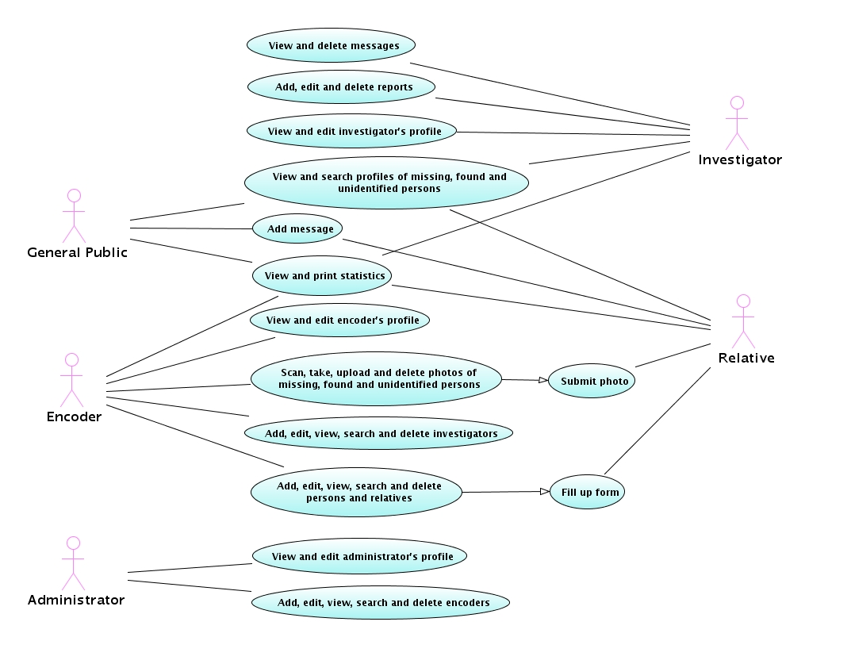Figure 2: Use case diagram of OpenMPIS.
Figure 3 describes the objects used in the system. Boundaries refer to Web pages, the controller is none other than the Struts ActionServlet that maps requested actions to matching entities and entities are the Java classes.

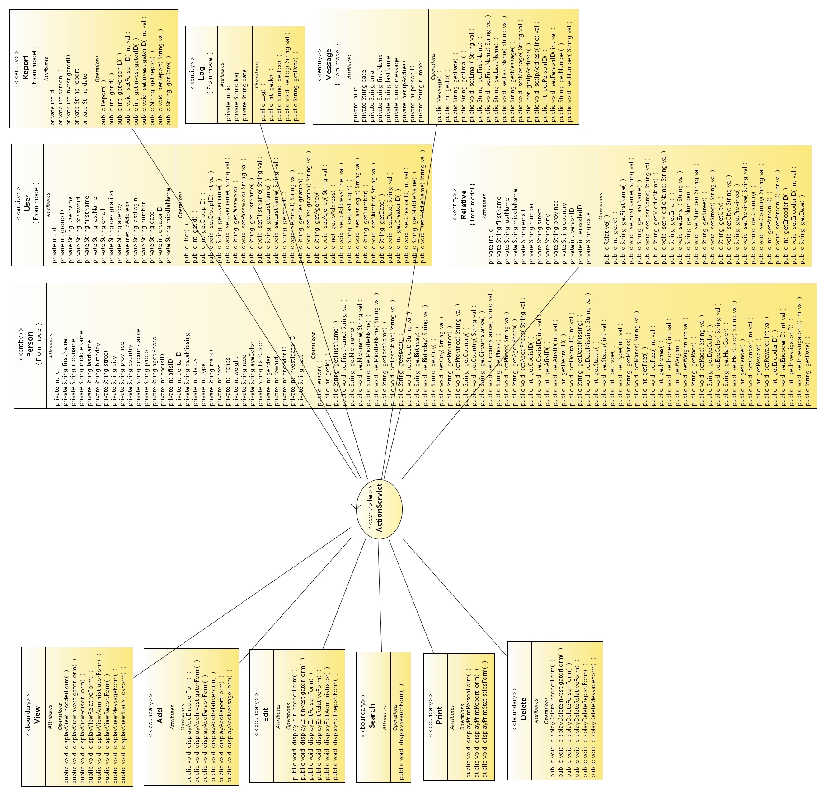Figure 3: Class diagram of OpenMPIS.
Figure 4 illustrates how an object retrieves and inserts data into the database. The Java object accesses the thread-safe, long-lived service object. This SQL Map Client service object accesses the SQL Map Configuration which connects to the database and reads the SQL Maps containing all the needed SQL statements. The Map Client returns the needed object.

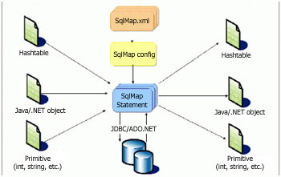Figure 4: Data model of OpenMPIS (iBATIS) from the iBATIS Web site.
The OpenMPIS database schema was developed using Druid. It contains 7 tables, namely: abductor, person, relative, log, message, report and user (administrator, investigator and encoder). A missing, found or unidentified person's data is stored on the person table. The relative who reports the person is stored on the relative table. System accesses will be added to the log table. The message table will contain information submitted by citizens pertaining to the missing or found person. User table stores the data on the administrator, investigators and encoders. The report table contains the progress reports of investigators for a given person.
Figure 5 shows a snapshot of an online mind map created to visualize and organize ideas. It can be viewed at http://www.mindomo.com/view?m=68f5b9cf7c090593d0f29cb94497822c. It also serves as a project monitoring tool because it can reflect the progress of the modules.
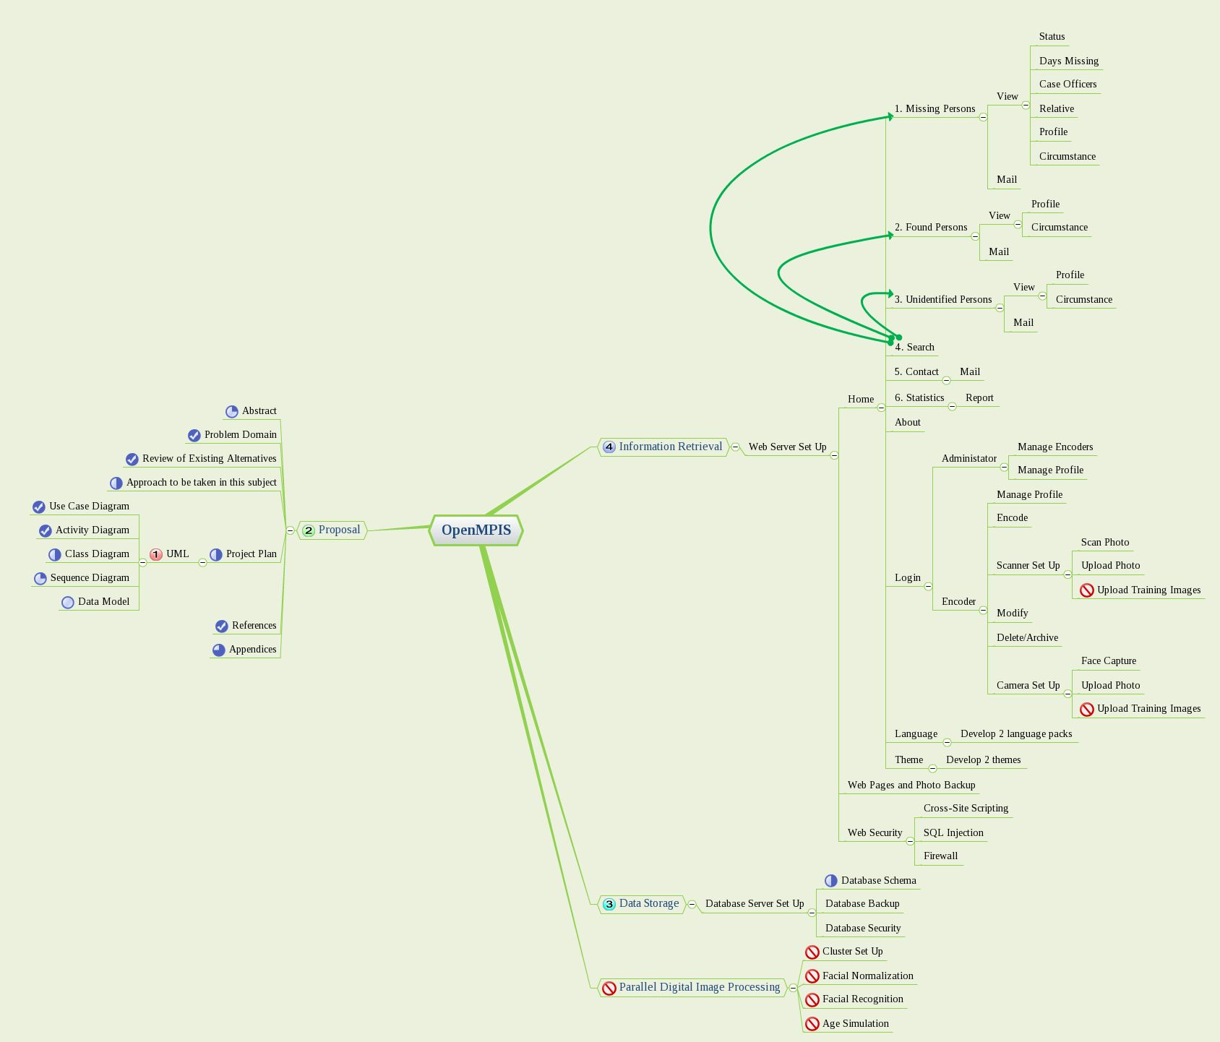Figure 5: Online mind map of OpenMPIS.
The following are the key features of the system:
- Separation of the style and the text
To allow customization, themes using cascading style sheets are used to change the look of the Web pages.
- Separation of the presentation or interface and the data or model through an intermediate component
The use of the MVC architecture simplified the developer's concentration and aided in troubleshooting the application.
- Separation of the business logic and the persistence logic
The use of persistence framework through iBATIS' Data Access Object (DAO) instead of Hibernate's Object-Relational Mapping (ORM) was precipitated by DAO's simplicity, separation of data (Data Transfer Objects) and behavior (DAO), consideration for distributed architectures, lack of runtime container and capacity to generate highly efficient code (Grove, 2005). By separating business logic from persistence logic, the system can utilize any available database server.
- Separation of offline and online work
Visitors can easily copy statistical data right off the Web site or generate PDF versions. Encoders can also generate reports aside from statistics for record-keeping purposes.
- Separation of language-specific strings from hard-coded texts
To enable internationalization of the system, language-specific strings are placed in resource properties. This allows anyone to create texts for their locale. English version is the only language available for the initial version.
- Separation of tasks among the various agencies
The administrator can create encoders from all cooperating agencies. Encoders input a person's profile and contact information of the relative and delegate investigators to that case thus, dividing the workload to speed up dissemination and action.
- Incorporation of provisions for Parallel Digital Image Processing
Since the initial goal was to develop an age progression software, the database, form and interface have certain elements that will take into account this particular upgrade.

B. Methods
For the design studies, all possible users of the information systems were identified and envisioned what they should do with respect to the system. Books, articles and tutorials on JSP, Java, Struts and iBATIS were read and existing systems were reviewed to acquire designs, standards and best practices. New references were also added.
In reviewing existing systems and related literature, various operational missing persons information system from developed countries were examined to understand how they work. Sourceforge was searched for similar open source projects. Attempts to locate at least one system from the Philippines proved to be futile. The NBI, PNP and DSWD were asked what they use or why their system is not operational but to no avail.
In assessing existing alternatives, descriptions of projects currently under development were read, screenshots were viewed, and operational systems abroad were tested. A comparative paper between the finished information system and the Western counterparts can be made later.
A publicly-accessible sandbox which can be tested by some personnels from the PNP, NBI and DSWD can be set up after express permission is granted by ASTI to host the system on a virtual server with a temporary fully-qualified domain name, preferably http://www.missingfilipinos.gov.ph, The system may be demonstrated to some senators or any of the 3 agencies mentioned above.
In developing assessment instruments, test cases can be drafted and carried out by friends or relatives to check if the desired results have been achieved. Bugs and recommendations will be grounds for revision of the prototype. Once all test cases have been fully satisfied, the system is considered bug-free.

C. Plan for user testing and project assessment
The problem that was identified is the lack of a free, open source and operational information system currently available for download that could address the lack of centralized service for disseminating advisories to and requesting help from the public and the lack of consolidated effort for locating missing Filipinos. The project can be considered a success if all the requirements have been met, the code has been released into the public domain and a sandbox has been deployed for the country.
The following questions are to be answered:
- How does implementing a missing persons information system integrate and consolidate government efforts in finding missing, abducted and runaway persons and reporting throwaway, abandoned, found and unidentified persons?
- How can concerned citizens be informed and encouraged to look out for these missing persons?
- How will this information system benefit from being a free and open source software?
Functional testing on the information system can be conducted. The black box testers can play the roles of the administrator, encoder, investigator and concerned citizen; access an online document containing the test case; and append the results of their tests. The gathered test case results will determine if all key features and functionalities are working properly under any condition. The findings help pinpoint defects and rectify them immediately before they escalate and pose bigger threats.

D. Plan for collaboration (For collaborative projects only)
Not applicable.

V. Results and Discussions
- Integration and consolidation of efforts
The Open Source Missing Persons Information System offers multi-user and multi-organization operations from a single Information System. Clerks and law enforcers from the PNP, NBI and DSWD, together with concerned citizens, human rights advocates and the media, can track the progress of any investigation and provide adequate action to solving a case. OpenMPIS allows downloading of statistical data.
These functionalities infer that an e-Government portal such as OpenMPIS can accelerate solving cases of missing, found and unidentified persons through publicity and progress reports. The data can be used by our leaders and law-makers in proposing new measures which can prevent or at least mitigate disappearances and abductions.
- Centralization of advisory dissemination to the public
The Open Source Missing Persons Information System is a one-stop site for browsing missing, abducted, runaway, throwaway, abandoned, found and unidentified persons. It provides safety tips to keep children and loved ones safe. It also solicits the help of concerned citizens in providing useful information or sightings on missing persons. Posters can be easily printed and distributed or attached to bulletin boards.
These features may suggest that citizens who frequently visit the site will be able to spot missing persons and contribute in reuniting them with their families, as well as learn valuable lessons in keeping their own relatives safe. There won't be any need for posting missing person advertisements in various blogs and forums because citizens can find them in one centralized location.
- Free, open source and operational information system
The Open Source Missing Persons Information System is licensed under the GNU General Public License. This allows organizations and government agencies to use the software free of charge, permits developers to modify and improve the source code by adding new features and functionalities and gives anyone the right to redistribute the software.
OpenMPIS is fully operational to the point that missing persons can already be encoded and their photos uploaded.
These indicate the readiness of the system for full-scale testing and security audit. Collaborating with other open source programmers will strengthen the system from malicious activities.
- Compliance with open systems
The following are the main characteristics of an open system according to Robert Domaingue (1992):
- The components interact harmoniously with one another forming a network of interdependent elements comprising a whole.
- A system is more than just the simple sum of its parts.
- If one component is defective, not capable of interacting correctly with the others, not fulfilling its particular function, the whole system is affected.
- Systems that relate to other systems are called open systems.
- It follows that systems function in relation to their environment, on which they depend for support and which they affect with their outputs.
- Most systems are subject to external constraints imposed by the environment, and internal constraints due to their own inherent limitations.
- Many systems, especially in biology, sociology and industry, have a tendency to reach and maintain a dynamic equilibrium (homeostasis).
Looking back at Figure 1, it becomes evident that the general system involving the relatives, the government agencies, the general public, the Information System, the missing persons and, to some extent, the abductors exhibit all or most of these characteristics. There is interaction among public servants and the public and there is interdependence from the relatives and missing persons. If the Information System is defective or the information provided is incorrect or the investigators are incompetent, then the entire system is affected.
Lars Skyttner (2005) compiled a list of properties that comprise a general system theory of open systems which include:
- Interrelationship and interdependence of objects and their attributes: Unrelated and independent elements can never constitute a system.
- Holism: Holistic properties not possible to detect by analysis should be possible to define in the system.
- Goal seeking: Systemic interaction must result in some goal or final state to be reached or some equilibrium point being approached.
- Transformation process: All systems, if they are to attain their goal, must transform inputs into outputs. In living systems this transformation is mainly of a cyclical nature.
- Inputs and outputs: In a closed system the inputs are determined once and for all; in an open system additional inputs are admitted from its environment.
- Entropy: This is the amount of disorder or randomness present in any system. All non-living systems tend toward disorder; left alone they will eventually lose all motion and degenerate into an inert mass. When this permanent stage is reached and no events occur, maximum entropy is attained. A living system can, for a finite time, avert this unalterable process by importing energy from its environment. It is then said to create negentropy, something which is characteristic of all kinds of life.
- Regulation: The interrelated objects constituting the system must be regulated in some fashion so that its goals can be realized. Regulation implies that necessary deviations will be detected and corrected. Feedback is therefore a requisite of effective control. Typical of surviving open systems is a stable state of dynamic equilibrium.
- Hierarchy: Systems are generally complex wholes made up of smaller subsystems. This nesting of systems within other systems is what is implied by hierarchy.
- Differentiation: In complex systems, specialized units perform specialized functions. This is a characteristic of all complex systems and may also be called specialization or division of labor.
- Equifinality and multifinality: Open systems have equally valid alternative ways of attaining the same objectives from different initial conditions (convergence) or, from a given initial state, obtain different, and mutually exclusive, objectives (divergence).
OpenMPIS has indications of the interrelationship and interdependence of the elements, goal-directedness which leans towards the reunion of families, transformation of paper-based data into online information, hierarchy in access levels and identification of duties and responsibilities.

VI. Conclusions
Implementing a missing persons information system integrates and consolidates government efforts in finding missing, abducted and runaway persons and reporting throwaway, abandoned, found and unidentified persons by tracking the progress made by investigators assigned to cases. Interaction among the lead agencies and the society hastens the solving of cases.
Concerned citizens are informed and encouraged to look out for these missing persons through online advisories. The system provides pertinent information regarding missing, found and unidentified persons together with their photos as well as information on abductors. The general public is likewise advised to keep their own loved ones safe.
OpenMPIS is guaranteed to deliver results and make waves in the e-Government realm. Being a free and open source software ensures that software developers whose passion is in the improvement of useful applications will contribute some of their knowledge in maintaining the source code. OpenMPIS' potential will be maximized once it achieves software stability and maturity and government agencies start using it. OpenMPIS also brings out the beauty of General System Theory.
In a broader sense, OpenMPIS can rival the in-house systems developed by the US, the UK and Canada within the next five years. Incorporation of new and exciting features will keep it up-to-date.

VII. Recommendations
Pursue funding for the continued improvement and eventual nationwide deployment of the system. Funding sources include DOST-PCASTRD.
Contact those who have a missing a loved one and ask them to file a missing person report using the Case Reporting Form.
A theme highlighting Philippine culture can be used for the locally-deployed version.
To be more far-reaching, a Tagalized version of texts can be drafted.
Access to support groups can be integrated into the system. This will allow relatives to share experiences, express sympathies and reassure one another.
A Geographic Information System can be added on the next major upgrade which can pinpoint the location where persons disappeared. Statistical data can be overlaid on a Google map to create a visualization of reported cases.
Forwarding of advisories through multimedia messages in cellular phones, although expensive, can be fast and effective. Mobile services can be explored on succeeding versions.
The age progression module may be available within the next five years. A high-performance computing cluster; Java 2D API and mpiJava or MPJ Express libraries for the software; and hundreds of pictures of Filipinos from various age groups will be utilized. Training images or dataset will be composed of photos of male and female subjects belonging to any of these 7 age groups: 1-10, 11-20, 21-30, 31-40, 41-50, 51-60 and 61-80. These images will be stored on a file server and shared across the computing nodes. The aged progressed photo will be placed alongside the raw image.
For facial image normalization, pose compensation, illumination compensation and facial expression compensation are major issues to be resolved. For facial image recognition, skin tone/region detection, YUV color domain, grayscale and principal component analysis algorithms will be evaluated to choose the most appropriate.
For the actual age simulation, various implementations have been proposed like historical and consensus aging, linear aging, piecewise aging, support vector machines, dynamic Markov process, RBF neural network and Bayesian framework.
Likewise, to accommodate more clients, a study on how to set up additional servers and load balancer has to be undertaken.
OpenMPIS can still be expounded in another paper as a case study on General System Theory.

VIII. References
Basham, B., Sierra, K. and Bates, B. (2004). Head First Servlets and JSP. Sebastopol, California, U.S.A.: O'Reilly Media, Inc.

Philippine Senate (2007). Jinggoy urges GMA to certify his bills as priority measures. http://senate.gov.ph/press_release/2007/0718_estradaj1.asp

Estrada, J. (2007). An Act Creating a Commission on Missing Persons.
http://senate.gov.ph/lis/bill_res.aspx?congress=14&q=SBN-429

Villar, M. (2007). An Act Creating the Missing Persons Council, Prescribing its Powers, Functions and Duties and Providing Funds Therefor. http://senate.gov.ph/lis/bill_res.aspx?congress=14&q=SBN-1709

Legarda, L. (2007). An Act Establishing a National Strategic Missing Children Recovery Program and for Other Purposes.
http://senate.gov.ph/lis/bill_res.aspx?congress=14&q=SBN-1385

Chalana.
http://sourceforge.net/projects/chalana

Sahana.
http://www.sahana.lk

Mass Casualty Disaster Data Collection.
http://sourceforge.net/projects/pcrx911

Grove, A. (2005). Data Access Object (DAO) versus Object Relational Mapping (ORM). http://www.codefutures.com/weblog/andygrove/archives/2005/02/data_access_obj.html

Schatten, A. (2006). The iBATIS Persistence Framework.
http://best-practice-software-engineering.blogspot.com/2006/11/pub-ibatis-persistence-framework.html

Wade, M. (2005). General Systems Theory. http://www.istheory.yorku.ca/generalsystemstheory.htm

Heylighen, F. and Joslyn, C. (1992). What is Systems Theory?
http://pespmc1.vub.ac.be/SYSTHEOR.html

Walonick, D. (2004). General Systems Theory.
http://www.survey-software-solutions.com/walonick/systems-theory.htm

Wikipedia 1. Systems Theory. http://en.wikipedia.org/wiki/General_systems_theory#Software_and_computing

Skyttner, L. (2005). General Systems Theory: Problems, Perspectives, Practice. http://books.google.com.ph/books?printsec=frontcover&dq=skyttner+general+systems+theory+problems&id=tG6QKNgYs9sC

Wikipedia 2. Software Design.
http://en.wikipedia.org/wiki/Software_design

iBATIS.
http://ibatis.apache.org/flow.jpg

Nelson, E. (2007). Open Architecture for the Enterprise. http://www.ibm.com/developerworks/library/ar-openarch1/index.html

Wikipedia 3. Black Box Testing.
http://en.wikipedia.org/wiki/Black_box_testing

Ray, F. (2000). General Systems Theory: A Knowledge Domain in Engineering Systems. http://web.mit.edu/esd.83/www/notebook/gst.pdf

Domaingue, R. (1992). Learning for Discovery: Establishing the Foundations
http://www.scientificexploration.org/journal/jse_06_1_domaingue.pdf

http://fritzified.com/2008/07/24/missing-child-matthew-chu-chu-david-samudio/

http://tsadyokaykoy.multiply.com/journal/item/15/Remember_Ma._Ysabelle_Sim

http://www.pinoyblogosphere.com/2007/06/17/help-missing-person/

VI. Appendices

A. Deliverables and Milestones
The proposal was submitted in March 2008.
The working prototype is submitted as part of the deliverables for March 2009. The online sandbox will be available later on.
The user testing and assessment plans and report of results are also available.
The milestones of the project are the following:
Date Deliverables
03/01/08 Project proposal submitted
03/09/09 Presentation
03/23/09 User testing and learning assessment complete
03/31/09 Final report submitted

B. Budget
Total budget for the project is limited to Internet connection fees, printing costs, travel to UP Los Baños. There is no need for procuring a separate development machine as the laptop computer will suffice.

C. Qualifications
The author has practical knowledge in the following programming and markup languages: J2SE, J2EE, C/C++, PERL, PHP, JSP, Servlets, CSS, Javascript, CGI and XHTML.
The author has extensive experience in using Linux (Red Hat, Fedora, Debian and Ubuntu), FreeBSD, Solaris and MS Windows. The author is adept at using and managing PostgreSQL and MySQL database servers, Apache Web server and Tomcat container.
The author is also skilled in IPv4 and IPv6 computer networking, OpenOffice and MS Office applications, cluster computing using MPICH2 and grid computing using Globus Toolkit 4.
Some of the author's accomplishments while working for the Advanced Science and Technology Institute are the following:
- set up the Philippine e-Science Grid Web site, wiki, monitor, cluster sandbox, grid sandbox and certificate authority sandbox
- currently the team leader of the Philippine Bioinformatics Solutions project
- set up the Philippine Bio-Mirror node
- set up the Philippine S-Star node
- co-develop GenBank Entry Retrieval System
- set up test bed for voice over IPv6
- customize PhpMyLibrary Library Management System and Greenstone Digital Library for ASTI, LGRC and CHED
- deploy and document IPv6 network services
- test Z39.50 protocol functionality for PhpMyLibrary
- co-develop Pawikan Network Management System
- set up APBioBox and SunBioBox
The papers the author has written, co-written, published and presented are:
- ASTI's Bioinformatics Initiative : Knowing APBioBox and Sun BioBox the Easy Way
  - presented at the 1st Annual Bioinformatics Conference and Convention of the Network for Integrative Multidisciplinary Bioinformatics Utilization Strategies (NIMBUS), Inc., International Rice Research Institute, October 15, 2004
- PAWIKAN : A Scalable Network Management System For Small, Medium and Large-Scale Networks
  - presented at the 5th National Conference on Electronics and Communications Engineering, Mapua Institute of Technology, November 26, 2004 and at the 20th APAN Meeting, Taiwan, August 23, 2005
- Grid Computing for Bioinformatics: A Review and Feasibility Study of the Available Grid Architectures, Software Packages and Database Systems
  - presented at the 8th National Electronics Communications and Computer Engineering Conference, PTTC, November 23, 2007 and at the Philippine Computing Science Congress 2008
The author has also conducted PhpMyLibrary and Greenstone trainings for LGRC-NCR, LGRC-7, LGA, LGSP and CHED on various dates and venues.
The author has also attended the following trainings:
- Java Short Course from Diliman Computer Science Foundation
- Advanced Java Training from Virtual Center for Technology Innovation – Information Technology
- Southeast Asia International Joint Research and Training Program in High-Performance Computing Applications and Networking Technology at the National Center for High-Performance Computing in Taiwan
- Grid Camp 2007, WLCG Tier-2 and EU-IndiaGrid Workshop at the Academia Sinica in Taiwan
- First EUAsiaGrid Training at MIMOS Berhad in Malaysia
New knowledge, skill and experience the author gained during his work on this project include Unified Modeling Language, Model-View-Controller architecture, internationalization of Web applications and iBATIS data mapping.
For his educational background, the author finished elementary at La Consolacion College – Iriga City with honors in 1995 and high school in 1999 as third honorable mention. The author graduated from UP Diliman on March 2004 with a degree of Bachelor of Science in Computer Science. The author was also a DOST Scholar at that time. The author immediately started working for the Advanced Science and Technology Institute before taking up Master in Information Systems 2 years later.

D. Contributors / Collaborators
Not applicable.

E. Resources
The resources the author needs for the project are a laptop computer as a development and test machine; Internet access for research purposes; free and open source software for the development environment and servers; books; documentations and others.

F. Complete Program Listing
The distribution, as checked out from Google Code, contains the following files and folders:
- README – contains information pertaining to the system, the requirements and the installation procedures, among others
- LICENSE – the GNU General Public License version 2
- build.xml – the Ant build file which automates the compilation of the source codes, the creation of the documentation, the installation of the database schema and creation of the deployable WAR file. The build/ and dist/ directories containing the compiled codes, Java documentation and the WAR file will then be created.
- conf/manifest.mf – the manifest file
- conf/META-INF/context.xml – the context file
- database/ – the directory containing the database schema for MySQL and database and the Druid file
- manuals/ – the directory containing the user, developer and system administrator manuals and database documentation
- nbproject/ – the NetBeans project directory
- src/ – the directory containing the Java Server Pages and source codes
- test/ – the directory for unit tests
- web/images/ – the directory for system images
- web/META-INF/context.xml – the context file for OpenMPIS
- web/photo/ – the directory for persons and abductor images
- web/scripts/md5.js – a JavaScript implementation of the MD5 Message Digest Algorithm, by RSA Data Security, Inc., as defined in RFC 1321. This was written by Paul Johnston et al. and distributed under the BSD License
- web/scripts/openmpis.js - custom JavaScripts for OpenMPIS including automatic generation of cities or municipalities for any given province in the Philippines
- web/styles/missingfilipinos.css – the customized stylesheet for http://missingfilipinos.gov.ph
- web/styles/openmpis.css – the default stylesheet of OpenMPIS
- web/WEB-INF/ – the directory containing all the JSP's, TLD's and other configuration files
- web/index.jsp – the home page
- web/robots.txt – restricts search engines by excluding some directories
- web/sitemap.xml – allows search engines to crawl the site more intelligently
Third party tools embedded or used in the system include:
- Struts, licensed under the Apache License, is used for mapping actions to various Java beans and for handling forms.
- iBATIS, licensed under the Apache License, is used for persisting data.
- JSTL, licensed under the Apache License, is used for adding functionalities to JSP's through additional tags.
- log4j, licensed under the Apache License, is used for logging events to a file.
- JavaMail which is licensed under the Common Development and Distribution License.
- iText, licensed under the Mozilla Public License and GNU Lesser General Public License, is used for generating PDF files.
- MySQL JDBC, licensed under the GNU General Public License, is used by Java for accessing MySQL databases.
- MD5.js, licensed under the BSD License, is a JavaScript file for creating MD5-encrypted passwords.

G. Technical Reference
- Final system specifications
- OpenMPIS was developed and tested on a laptop with a 2.2GHz dual core processor and 4GB of RAM. It uses 80MB of disk space upon compilation. The OpenMPIS Web archive file (openmpis.war) is only 6MB and this is deployed into Tomcat's webapps directory.
- OpenMPIS can run on any operating system.
- OpenMPIS depends on Java 1.6 for compilation and operations.
- OpenMPIS runs on Tomcat 6 and GlassFish v2 application servers. The former is highly recommended. OpenMPIS also requires a MySQL 5 database server.
- Maintenance plan for the software system
- Please refer to the OpenMPIS Developer Manual for a list of the location and content of all relevant files, to the OpenMPIS System Administration Manual for installing, compiling and configuring the system and to the OpenMPIS Database Documentation for the database schema details.
- OpenMPIS depends on Ant 1.6 for automated compilation.

H. User Manual
Please refer to the OpenMPIS User Manual for the instructions on how to use the system.

I. List of Figures
Figure 1 21
Figure 2 26
Figure 3 28
Figure 4 29
Figure 5 31

